A Survey on Machine Learning Techniques with Applications

Randeep Kaur(Author)
Assistant Professor
Khalsa Institute Of Management & Technology for Women
Ludhiana, India

Abstract—Machine learning is one of the most stimulating recent technologies in Artificial Intelligence. Machine learning is an integral part of artificial intelligence, which is used to design algorithms based on the data trends and historical relationships between data. This paper introduces the definition of machine learning and its basic structure, and describes a variety of machine learning techniques. In each of our study we found that the results of various machine-learning techniques depends on application areas on which they are applied. In this paper, a brief review and future prospect of the vast applications of machine learning has been made.

Keywords-Artificial intelligence,Machine Learning,Supervised Learning,Unsupervised Learning.

Introduction
Machine learning, which is a field that had grown out of the field of artificial intelligence, is of utmost importance as it enables the machines to gain human like intelligence without explicit programming. Machine Learning is like farming or gardening. Seeds are the algorithms, nutrients are the data, the gardener is you and plant is the programs. Machine learning is the science of getting computers to act without being explicitly programmed. In the past decade, machine learning has given us self-driving cars, practical speech recognition, effective web search, and a vastly improved understanding of the human genome. Machine learning is so pervasive today that you probably use it dozens of times a day without knowing it. Many researchers also think it is the best way to make progress towards human-level AI. Machine Learning (ML) is coming into its own, with a growing recognition that ML can play a key role in a wide range of critical applications, such as data mining, natural language processing, image recognition, and expert systems.

MACHINE LEARNING

SUPERVISED LEARNING
UNSUPERVISED
LEARNING
SUPER

CLASSIFICATION
TECHNIQUES
REGRESSION
TECHNIQUES
CLUSTERING
TECHNIQUES

ML provides potential solutions in all these domains and more, and is set to be a pillar of our future civilization. Machine learning can be segmented into supervised and unsupervised algorithms, and then further into the types of outputs they are trying to achieve — classification, regression or clustering. Machine learning differs from classical calculations in that it has the ability to ‘learn’ and make decisions (based on set parameters) as to how it should structure itself in order to achieve an optimal outcome. For example it can access the metrics used to measure the model’s accuracy to change parameters, thus self-optimizing. The ultimate test of machine learning is its ability to produce systems that are used regularly in industry, education, and elsewhere.

Types of machine learning algorithms

Supervised Learning
This learning process is based on the comparison of computed output and expected output, that is learning refers to computing the error and adjusting the error for achieving the expected output.. Machine learning algorithms are described as learning a target function (f) that best maps input variables (X) to an output variable (Y): Y = f(X) This is a general learning task where we would like to make predictions in the future (Y) given new examples of input variables (X). We don’t know what the function (f) looks like or its form. If we did, we would use it directly and we would not need to learn it from data using machine learning algorithms. The most common type of machine learning is to learn the mapping Y = f(X) to make predictions of Y for new X. This is called predictive modeling or predictive analytics and our goal is to make the most accurate predictions possible. The goal of supervised learning is to build a concise model of the distribution of class labels in terms of predictor features. The resulting classifier is then used to assign class labels to the testing instances where the values of the predictor features are known, but the value of the class label is unknown. Supervised learning is divided into classification and regression.

Unsupervised Learning
Unsupervised machine learning algorithms infer patterns from a dataset without reference to known or labeled outcomes. Unlike supervised machine learning, unsupervised machine learning methods cannot be directly applied to a regression or classification problem because you have no idea what the values for the output data might be, making it impossible for you to train the algorithm the way you normally would. Unsupervised learning can instead be used for discovering the underlying structure of the data. In this learning the data are divided into different clusters and hence the learning is called a clustering algorithm. Unsupervised machine learning purports to uncover previously unknown patterns in data, but most of the time these patterns are poor approximations of what supervised machine learning can achieve. Unsupervised learning is very useful in exploratory analysis because it can automatically identify structure in data. For example, if an analyst were trying to segment consumers, unsupervised clustering methods would be a great starting point for their analysis. In situations where it is either impossible or impractical for a human to propose trends in the data, unsupervised learning can provide initial insights that can then be used to test individual hypotheses. Unsupervised learning methods are used in bioinformatics for sequence analysis and genetic clustering; in data mining for sequence and pattern mining in medical imaging for image segmentation; and in computer vision for object recognition.

Classification Techniques
Classification techniques predict discrete responses—for example, whether an email is genuine or spam, or whether a tumor is cancerous or benign. Classification models classify input data into categories. Typical applications include medical imaging, speech recognition, and credit scoring Use classification if your data can be tagged, categorized, or separated into specific groups or classes. . For example, applications for hand-writing recognition use classification to recognize letters and numbers. In image processing and computer vision, unsupervised pattern recognition techniques are used for object detection and image segmentation. Various algorithms which are used for classification are mentioned in the coming sections.

Support Vector Machine
Support Vector Machine (SVM) is a supervised machine learning algorithm which can be used for both classification and regression challenges. However, it is mostly used in classification problems. In this algorithm, we plot each data item as a point in n-dimensional space (where n is number of features you have) with the value of each feature being the value of a particular coordinate. In SVM, a hyperplane is selected to best separate the points in the input variable space by their class, either class 0 or class 1. In two-dimensions, you can visualize this as a line and let’s assume that all of our input points can be completely separated by this line. The SVM learning algorithm finds the coefficients those results in the best separation of the classes by the hyperplane.
The distance between the hyperplane and the closest data points is referred to as the margin. The best or optimal hyperplane that can separate the two classes is the line that has the largest margin. Only these points are relevant in defining the hyperplane and in the construction of the classifier. These points are called the support vectors. They support or define the hyperplane. In practice, an optimization algorithm is used to find the values for the coefficients that maximizes the margin. SVM might be one of the most powerful out-of-the-box classifiers and worth trying on your dataset.
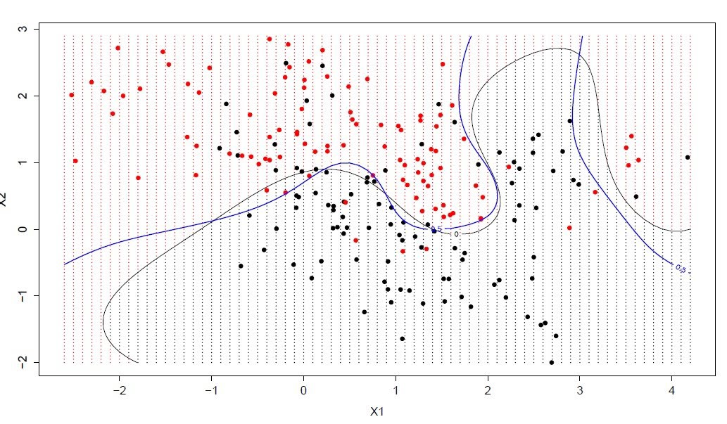
Fig 1. Support vector machine

Discriminent Analysis
The representation of LDA is pretty straight forward. It consists of statistical properties of your data, calculated for each class. For a single input variable this includes:
- The mean value for each class.
- The variance calculated across all classes.

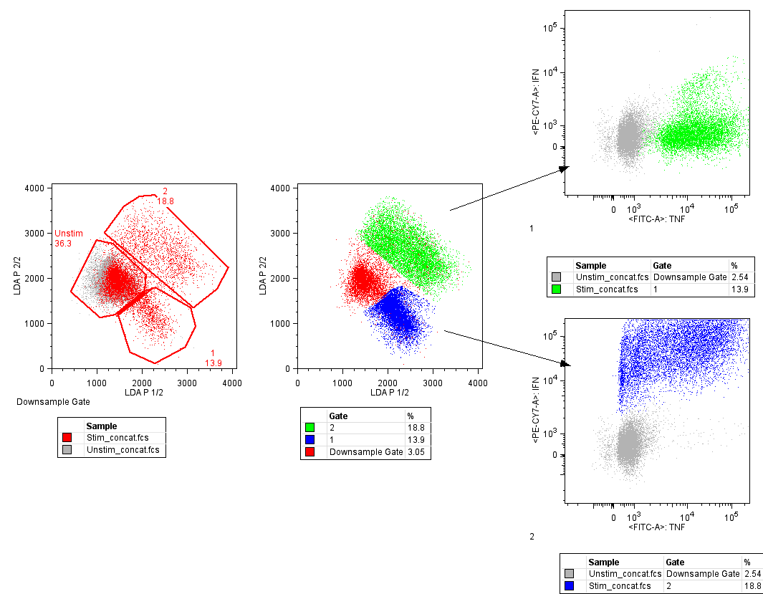

Fig 2. Discriminant analysis

Predictions are made by calculating a discriminate value for each class and making a prediction for the class with the largest value. The technique assumes that the data has a Gaussian distribution (bell curve), so it is a good idea to remove outliers from your data beforehand. It’s a simple and powerful method for classification predictive modeling problems.

Naïve Bayes
It is a classification technique based on Bayes’ Theorem with an assumption of independence among predictors. In simple terms, a Naive Bayes classifier assumes that the presence of a particular feature in a class is unrelated to the presence of any other feature. For example, a fruit may be considered to be an apple if it is red, round, and about 3 inches in diameter. . Even if these features depend on each other or upon the existence of the other features, all of these properties independently contribute to the probability that this fruit is an apple and that is why it is known as ‘Naive’.
Naive Bayes model is easy to build and particularly useful for very large data sets. Along with simplicity, Naive Bayes is known to outperform even highly sophisticated classification methods.
Bayes theorem provides a way of calculating posterior probability P(c | x) from P(c), P(x) and P(x | c). Look at the equation
P(c|x) =
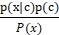

Above,
- P(c|x) is the posterior probability of class (c, target) given predictor (x, attributes).
- P(c) is the prior probability of class.
- P(x|c) is the likelihood which is the probability of predictor given class.
- P(x) is the prior probability of predictor.

K-Nearest Neighbor
The KNN algorithm is very simple and very effective. The model representation for KNN is the entire training dataset.
Predictions are made for a new data point by searching through the entire training set for the K most similar instances (the neighbors) and summarizing the output variable for those K instances. For regression problems, this might be the mean output variable, for classification problems this might be the mode (or most common) class value. The trick is in how to determine the similarity between the data instances. The simplest technique if your attributes are all of the same scale (all in inches for example) is to use the Euclidean distance, a number you can calculate directly based on the differences between each input variable.
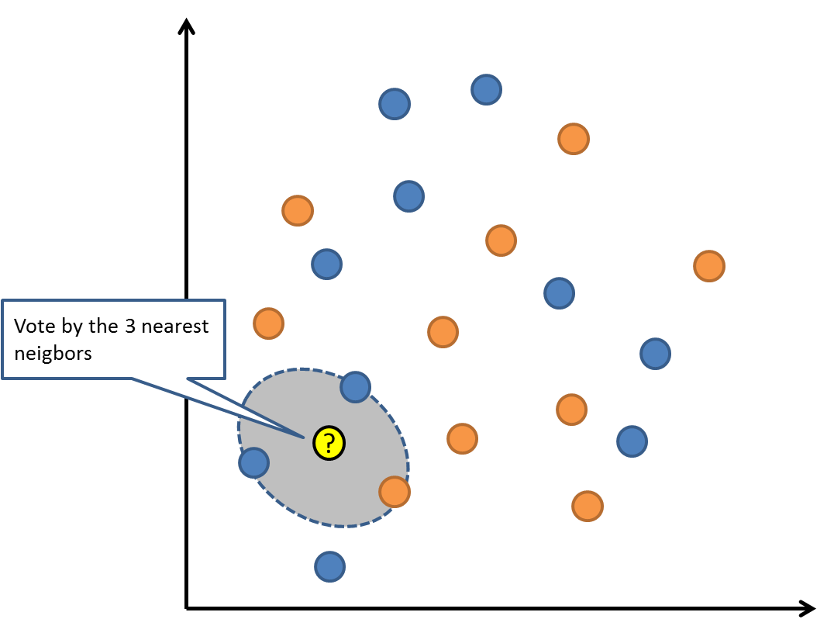

Fig 3. Nearest Neighbor

prediction is needed, just in time. You can also update and curate your training instances over time to keep predictions accurate. The idea of distance or closeness can break down in very high dimensions (lots of input variables) which can negatively affect the performance of the algorithm on your problem. This is called the curse of dimensionality. It suggests you only use those input variables that are most relevant to redacting the output variable.

Regression Techniques
Regression techniques predict continuous responses—for example, changes in temperature or fluctuations in power demand. Typical applications include electricity load forecasting and algorithmic trading. Use regression techniques if you are working with a data range or if the nature of your response is a real number, such as temperature or the time until failure for a piece of equipment.

Linear Regression
Linear regression is perhaps one of the most well-known and well-understood algorithms in statistics and machine learning. The representation of linear regression is an equation that describes a line that best fits the relationship between the input variables (x) and the output variables (y), by finding specific weightings for the input variables called coefficients (B)
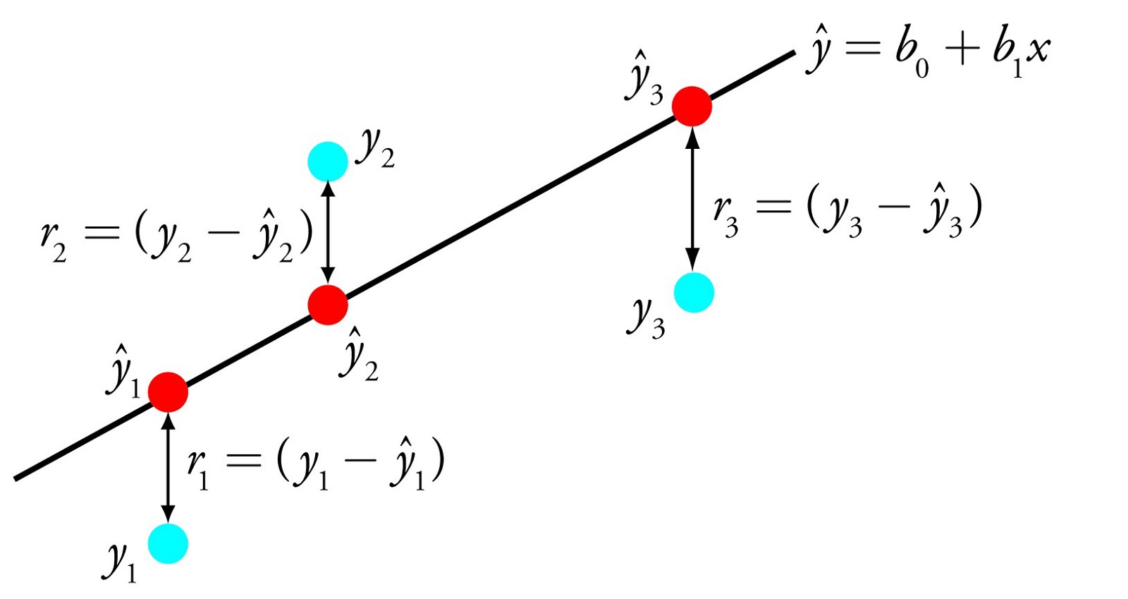
Fig 4. Linear Regression
For example: y = B0 + B1 * x
We will predict y given the input x and the goal of the linear regression learning algorithm is to find the values for the coefficients B0 and B1.It is a fast and simple technique and good first algorithm to try.

Neural Networks
The neural network (or artificial neural network or ANN)
is derived from the biological concept of neurons. A neuron
is a cell like structure in a brain. To understand neural
network, one must understand how a neuron works. A
neuron has mainly four parts . They are dendrites, nucleus, soma and axon. The dendrites receive electrical signals. Soma processes the electrical signal. The output of the process is carried by the axon to the dendrite terminals where the output is sent to next neuron. The nucleus is the heart of the neuron. The inter-connection of neuron is called neural network where
electrical impulses travel around the brain. Neural network research is motivated by two desires: to obtain a better understanding of the human brain, and to develop computers that can deal with abstract and poorly defined problems. For example, conventional computers have trouble understanding speech and recognizing people's faces. In comparison, humans do extremely well at these tasks.

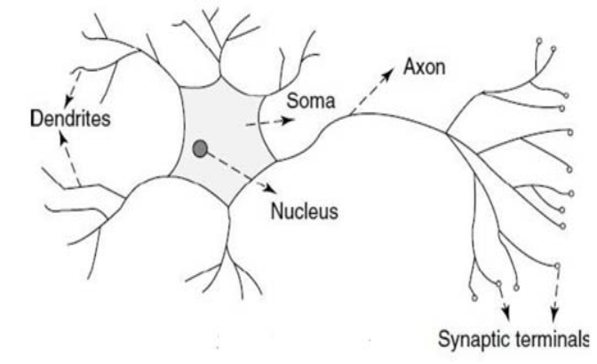

Fig 5. Neural Networks

Many different neural network structures have been tried, some based on imitating what a biologist sees under the microscope, some based on a more mathematical analysis of the problem.

Decision Trees
Decision Trees are an important type of algorithm for predictive modeling machinelearning.The representation of the decision tree model is a binary tree. This is your binary tree from algorithms and data structures, nothing too fancy. Each node represents a single input variable (x) and a split point on that variable (assuming the variable is numeric).

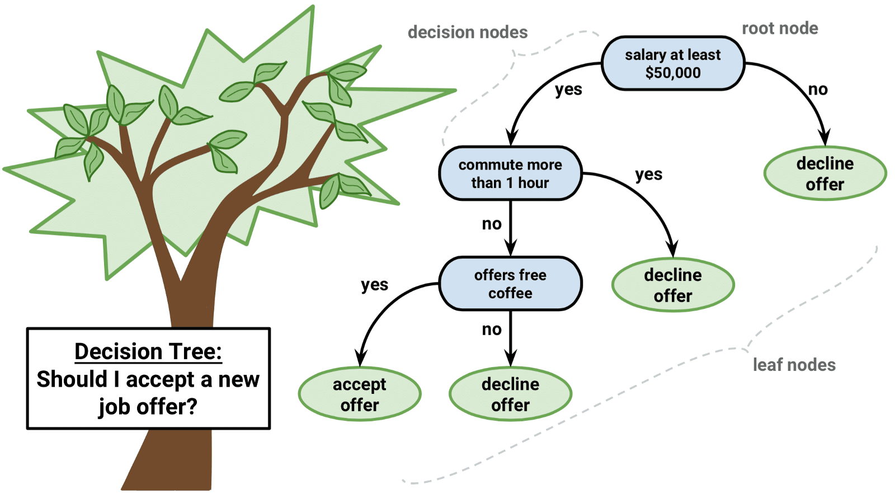

Fig 6. Decision Tree

.
The leaf nodes of the tree contain an output variable (y) which is used to make a prediction. Predictions are made by walking the splits of the tree until arriving at a leaf node and output the class value at that leaf node.
Trees are fast to learn and very fast for making predictions. They are also often accurate for a broad range of problems and do not require any special preparation for your data.

Clustering Techniques
Clustering is the most common unsupervised learning technique. It is used for exploratory data analysis to find hidden patterns or groupings in data. Applications for cluster analysis include gene sequence analysis, market research, and object recognition. For example, if a cell phone company wants optimize the locations where they build cell phone towers, they can use machine learning to estimate the number of clusters of people relying on their towers. A phone can only talk to one tower at a time, so the team uses clustering algorithms to design the best placement of cell towers to optimize signal reception for groups, or clusters, of their customers.

K-Means
k-means is one of the simplest unsupervised learning algorithms that solve the well-known clustering problem. The procedure follows a simple and easy way to classify a given data set through a certain number of clusters (assume k clusters) fixed priory. The main idea is to define k centers, one for each cluster. These centers should be placed in a cunning way because of different location causes different result. So, the better choice is to place them as much as possible far away from each other. The next step is to take each point belonging to a given data set and associate it to the nearest center. When no point is pending, the first step is completed and an early group age is done. At this point we need to re-calculate k new centroids as barycenter of the clusters resulting from the previous step. After we have these k new centroids, a new binding has to be done between the same data set points and the nearest new center. A loop has been generated. As a result of this loop we may notice that the k centers change their location step by step until no more changes are done or in other words centers do not move any more.
Finally, this algorithm aims at minimizing an objective function know as squared error function given by:

where,
‘||x_{i} - v_{j}||’ is the Euclidean distance between x_{i} and v_{j.}
‘c_{i}’ is the number of data points in i^{th} cluster.
‘c’ is the number of cluster centers.

Gaussian Mixture Models
Gaussian Mixture Models (GMMs) give us more flexibility than K-Means. With GMMs we assume that the data points are Gaussian distributed; this is a less restrictive assumption than saying they are circular by using the mean. That way, we have two parameters to describe the shape of the clusters: the mean and the standard deviation! Taking an example in two dimensions, this means that the clusters can take any kind of elliptical shape (since we have standard deviation in both the x and y directions). Thus, each Gaussian distribution is assigned to a single clustering order to find the parameters of the Gaussian for each cluster (e.g. the mean and standard deviation) we will use an optimization algorithm called Expectation–Maximization (EM). Take a look at the graphic below as an illustration of the Gaussians being fitted to the clusters. Then we can proceed on to the process of Expectation–Maximization clustering using GMMs.
We begin by selecting the number of clusters (like K-Means does) and randomly initializing the Gaussian distribution parameters for each cluster. One can try to provide a good guesstimate for the initial parameters by taking a quick look at the data too. Though note, as can be seen in the graphic above, this isn’t 100% necessary as the Gaussians start our as very poor but are quickly optimized.
Given these Gaussian distributions for each cluster, compute the probability that each data point belongs to a particular cluster. The closer a point is to the Gaussian’s center, the more likely it belongs to that cluster. This should make intuitive sense since with a Gaussian distribution we are assuming that most of the data lies closer to the center of the cluster.
Based on these probabilities, we compute a new set of parameters for the Gaussian distributions such that we maximize the probabilities of data points within the clusters. We compute these new parameters using a weighted sum of the data point positions, where the weights are the probabilities of the data point belonging in that particular cluster. To explain this in a visual manner we can take a look at the graphic above, in particular the yellow cluster as an example. The distribution starts off randomly on the first iteration, but we can see that most of the yellow points are to the right of that distribution. When we compute a sum weighted by the probabilities, even though there are some points near the center, most of them are on the right. Thus naturally the distribution’s mean is shifted closer to those set of points. We can also see that most of the points are “top-right to bottom-left”. Therefore the standard deviation changes to create an ellipse that is more fitted to these points, in order to maximize the sum weighted by the probabilities.

Hierarchichal
Hierarchical clustering algorithms actually fall into 2 categories: top-down or bottom-up. Bottom-up algorithms treat each data point as a single cluster at the outset and then successively merge (or agglomerate) pairs of clusters until all clusters have been merged into a single cluster that contains all data points. Bottom-up hierarchical clustering is therefore called hierarchical agglomerative clustering or HAC. This hierarchy of clusters is represented as a tree (or dendrogram). The root of the tree is the unique cluster that gathers all the samples, the leaves being the clusters with only one sample.
We begin by treating each data point as a single cluster i.e if there are X data points in our dataset then we have X clusters. We then select a distance metric that measures the distance between two clusters. As an example we will use average linkage which defines the distance between two clusters to be the average distance between data points in the first cluster and data points in the second cluster.
On each iteration we combine two clusters into one. The two clusters to be combined are selected as those with the smallest average linkage. I.e according to our selected distance metric, these two clusters have the smallest distance between each other and therefore are the most similar and should be combined.
Step 2 is repeated until we reach the root of the tree i.e we only have one cluster which contains all data points. In this way we can select how many clusters we want in the end, simply by choosing when to stop combining the clusters i.e when we stop building the tree!
Hierarchical clustering does not require us to specify the number of clusters and we can even select which number of clusters looks best since we are building a tree. Additionally, the algorithm is not sensitive to the choice of distance metric; all of them tend to work equally well whereas with other clustering algorithms, the choice of distance metric is critical. A particularly good use case of hierarchical clustering methods is when the underlying data has a hierarchical structure and you want to recover the hierarchy; other clustering algorithms can’t do this. These advantages of hierarchical clustering come at the cost of lower efficiency, as it has a time complexity of O(n³), unlike the linear complexity of K-Means and GMM.

Real Life Applications of Machine learning
If you keep yourself updated about technology news, you are probably seeing mentions about machine learning everywhere- from voice assistants to self-driving cars, and for good reasons. Everyday a new app, product or service unveils that it is using machine learning to get smarter and better. This Section elaborates various application areas of machine learning

Health Care
Doctors and medical practitioners will soon be able to predict with accuracy on how long patients with fatal diseases will live. Medical systems will learn from data and help patients save money by skipping unnecessary tests. Radiologists will be replaced by machine learning algorithms. McKinsey Global Institute estimates that applying machine learning techniques to better inform decision making could generate up to $100 billion in value based on optimized innovation, enhanced efficiency of clinical trials and the creation of various novel tools for physicians, insurers and consumers. Computers and Robots cannot replace doctors or nurses, however the use of life-saving technology (machine learning) can definitely transform healthcare domain. When we talk about efficiency of machine learning, more data produces effective results – and the healthcare industry is residing on a data goldmine.

Fraud Detection
One of the core machine learning use cases in banking/finance domain is to combat fraud. Machine learning is best suited for this use case as it can scan through huge amounts of transactional data and identify if there is any unusual behaviour. Every transaction a customer makes is analysed in real-time and given a fraud-score that represents the likelihood of the transaction being fraudulent. If the fraud score is above a particular threshold, a rejection will be triggered automatically which would otherwise be difficult without the application of machine learning techniques as humans cannot reviews 1000’s of data points in seconds and make a decision.

In Retail for Product Recommendation
According to The Realities of Online Personalisation Report, 42% of retailers are using personalized product recommendations using machine learning technology. It is no secret that customers always look for personalized shopping experiences, and these recommendations increase the conversion rates for the retailers resulting in fantastic revenue. The moment you start browsing for items on Amazon, you see recommendations for products you are interested in as “Customers Who Bought this Product Also Bought” and “Customers who viewed this product also viewed”, as well specific tailored product recommendation on the home page, and through email. Amazon uses Artificial Neural Networks machine learning algorithm to generate these recommendations for you. To make smart personalized recommendations, Alibaba has developed “E-commerce Brain” that makes use of real-time online data to build machine learning models for predicting what customers want and recommending the relevant products based on their recent order history, bookmarking, commenting, browsing history, and other actions.

Dynamic Pricing
One of Uber’s biggest uses of machine learning comes in the form of surge pricing, a machine learning model nicknamed as “Geosurge” at Uber. If you are getting late for a meeting and you need to book an Uber in crowded area, get ready to pay twice the normal fare. In 2011, during New Year’s Eve in New York, Uber charged $37 to $135 for one mile journey. Uber leverages predictive modelling in real-time based on traffic patterns, supply and demand. Uber has acquired a patent on surge pricing. However, customer backlash on surge-pricing is strong, so Uber is using machine learning to predict where demand will be high so that drivers can prepare in advance to meet the demand, and surge pricing can be reduced to a greater extent.

VII Conclusion
This paper reviews various machine learning algorithms.
Today each and every person is using machine learning
knowingly or unknowingly. From getting a recommended
product in online shopping to updating photos in social
networking sites. This paper gives an introduction to most
of the popular machine learning algorithms. Being completely data-driven and having the ability to examine a large amount of data in smaller intervals of time,
ML algorithms has an edge over manual or direct programming. In the past machines have been used to reduce the manual labor required get a job done, but at present, with the advent of machine learning humans seek to build machines which are not only strong but also intelligent and hence machine learning has emerged to become an area of study that is ever in the bloom. Machine learning has not just made the machines autonomous, bringing forward the concept of autonomous computing, but it has also reduced the constant vigilance users are required to keep upon the applications. The main purpose of machine learning is to develop algorithms that assist in the creation of intelligent machines thus reducing the jobs of the programmers as the machine learns in due course of time to improve its performance. Although a lot of advancements have been made in this field still then there exists glaring limitations in the data set from which machine learns. It can be rectified by constantly keeping the data sets up-to-date as learning is a continuous process. The applications of machine learning are therefore never ending and it still remains an active field of research with immense development options and a promising future.

References
[1] W. Richert, L. P. Coelho, “Building Machine Learning Systems with
Python”, Packt Publishing Ltd., ISBN 978-1-78216-140-0
[2] M. Welling, “A First Encounter with Machine Learning”
[3] M. Bowles, “Machine Learning in Python: Essential Techniques for
Predictive Analytics”, John Wiley & Sons Inc., ISBN: 978-1-118-
96174-2
[4] S.B. Kotsiantis, “Supervised Machine Learning: A Review of
Classification Techniques”, Informatica 31 (2007) 249-268
[5] L. Rokach, O. Maimon, “Top – Down Induction of Decision Trees
Classifiers – A Survey”, IEEE Transactions on Systems,
[6] D. Lowd, P. Domingos, “Naïve Bayes Models for Probability
Estimation”
[7] https://webdocs.cs.ualberta.ca/~greiner/C-
651/Homework2_Fall2008.html
[8] D. Meyer, “Support Vector Machines – The Interface to libsvm in
package e1071”, August 2015
[9] S. S. Shwartz, Y. Singer, N. Srebro, “Pegasos: Primal Estimated sub -
Gradient Solver for SVM”, Proceedings of the 24th International
Conference on Machine Learning, Corvallis, OR, 2007
[10] Cunningham, Sally Jo, James Littin, and Ian H. Witten. "Applications of machine learning in information retrieval." (1997).
[11] Kaur, Harjinder, Gurpreet Singh, and Jaspreet Minhas. "A Review of Machine Learning based Anomaly Detection Techniques." arXiv preprint arXiv:1307.7286 (2013).
[12] Wiese, Bénard, and Christian Omlin. Credit card transactions, fraud detection, and machine learning: Modelling time with LSTM recurrent neural networks. Springer Berlin Heidelberg, 2009.
[13] Kumar, Vinod, and Dr Om Prakash Sangwan. "Signature Based Intrusion Detection System Using SNORT." International Journal of Computer Applications & Information Technology 1 (2012).
[14] Shen, Shunrong, Haomiao Jiang, and Tongda Zhang. "Stock market forecasting using machine learning algorithms." (2012).
[15] Pang, Bo, Lillian Lee, and Shivakumar Vaithyanathan. "Thumbs up?: sentiment classification using machine learning techniques." Proceedings of the ACL-02 conference on Empirical methods in natural language processing-Volume 10. Association for Computational Linguistics, 2002.
[16] Liao, Shih-wei, et al. "Machine learning-based prefetch optimization for data center applications." Proceedings of the Conference on High Performance Computing Networking, Storage and Analysis. ACM, 2009.
[17] Haider, Peter, Luca Chiarandini, and Ulf Brefeld. "Discriminative clustering for market segmentation." Proceedings of the 18th ACM SIGKDD international conference on Knowledge discovery and data mining. ACM, 2012.
[18] Haider, Peter, Luca Chiarandini, and Ulf Brefeld. "Discriminative clustering for market segmentation." Proceedings of the 18th ACM SIGKDD international conference on Knowledge discovery and data mining. ACM, 2012.
[19] Haykin, Simon, and Zhe Chen. "The cocktail party problem." Neural computation 17.9 (2005): 1875-1902.
[20] Clarke, Bertrand, Ernest Fokoue, and Hao Helen Zhang. Principles and theory for data mining and machine learning. Springer Science & Business Media, 2009.
[21] Kononenko, Igor. "Machine learning for medical diagnosis: history, state of the art and perspective." Artificial Intelligence in medicine 23.1 (2001): 89-109.
[22] Caragea, Cornelia, and Vasant Honavar. "Machine Learning in Computational Biology." Encyclopedia of Database Systems (2009): 1663-1667.
[23] Cho, Sung-Bae, and Hong-Hee Won. "Machine learning in DNA microarray analysis for cancer classification." Proceedings of the First Asia-Pacific bioinformatics conference on Bioinformatics 2003-Volume 19. Australian Computer Society, Inc., 2003.
[24] Wagstaff, Kiri. "Machine learning that matters." arXiv preprint arXiv:1206.4656 (2012).

